Morning Star Seminary Feb 2026
Let us examine each of the sixteen conciliar texts from Vatican II.
Our aim remains scholarly rigour suitable for graduate and postgraduate theological inquiry.
- Constitution on the Sacred Liturgy (Sacrosanctum Concilium, 4 December 1963)
The constitution does not merely “order” revision but establishes principled norms for reform rooted in tradition and pastoral necessity.
Sacrosanctum Concilium reclaims the liturgy as the communal act of the entire Christ—head and members—calling for conscious, active, and fruitful participation (actuosa participatio) through simplified rites, vernacular languages, and restored biblical and patristic elements. Illustration: The introduction of the vernacular into the Roman Missal permitted Indian Catholics in Kerala to hear the Eucharistic Prayer in Malayalam rather than Latin alone, transforming passive attendance into engaged worship. The restoration of the Prayer of the Faithful after the Gospel revived an ancient practice, enabling local communities to intercede for concrete needs such as monsoon floods or persecuted minorities.
- Decree on the Instruments of Social Communication (Inter Mirifica, 4 December 1963)
It called on members of the church, especially the laity, to instill “a human and Christian spirit” into newspapers, magazines, books, films, radio and television. It also speaks on the hierarchical responsibility and moral formation aspects.
Inter Mirifica recognises modern media as gifts of God while insisting on their ethical use, urging both clergy and laity to form consciences capable of infusing mass communication with truth, justice, and charity. Illustration: In post-conciliar India, Catholic journalists associated with publications like The Examiner (Bombay) or The New Leader (Madras) consciously sought to counter communal propaganda during tense periods, offering reporting marked by respect for human dignity across religious lines.
- Dogmatic Constitution on the Church (Lumen Gentium, 21 November 1964)
It presented the church as a mystery, as a communion of baptized believers, as the people of God, as the body of Christ and as a pilgrim moving toward fulfillment in heaven but marked on earth with “a sanctity that is real, although imperfect.”
Lumen Gentium articulates a rich ecclesiology of communion, shifting from a predominantly hierarchical-pyramidal model toward a sacramental mystery in which all members—laity, religious, clergy, bishops—share diverse gifts for the building up of the Body of Christ. Illustration: Chapter 5 on the universal call to holiness demolished the earlier notion that sanctity belonged chiefly to vowed religious; an Indian example is the beatification of lay martyr Devasahayam Pillai, whose ordinary married life manifested heroic virtue.
- Decree on Ecumenism (Unitatis Redintegratio, 21 November 1964)
Ecumenism should be everyone’s concern and that genuine ecumenism involves a continual personal and institutional renewal. The Church acknowledges real spiritual goodness and sacred elements present among Christians who are not in full unity. Separated brethren as “elements of sanctification.”
The decree inaugurates Catholic commitment to visible unity, grounding ecumenism in interior conversion (metanoia) and recognising that other Christian communities possess authentic means of grace. Illustration: The establishment of the Joint Working Group between the Catholic Church and the World Council of Churches, and in India the formation of united Bible translation projects among Catholics, Protestants, and Orthodox.
- Decree on Eastern Catholic Churches (Orientalium Ecclesiarum, 21 November 1964) It stated that variety within the church does not harm its unity and that Eastern Catholic churches should retain their own traditions.
Orientalium Ecclesiarum affirms the equal dignity of Eastern liturgical, theological, and disciplinary patrimonies, urging their preservation and revitalisation against past Latinisation tendencies. Illustration: The restoration of the Syro-Malabar Churchs own liturgical calendar and the reinstatement of married clergy in their traditional territories in India.
- Decree on the Bishops Pastoral Office in the Church (Christus Dominus, 28 October 1965)
Christus Dominus balances episcopal collegiality with primacy, encouraging national episcopal conferences while affirming each bishops full ordinary jurisdiction in his diocese. Illustration: The creation of the Catholic Bishops Conference of India (CBCI) as a deliberative body capable of issuing pastoral guidelines on social issues like caste discrimination.
- Decree on Priestly Formation (Optatam Totius, 28 October 1965)
The decree mandates integral formation—human, spiritual, intellectual, pastoral—oriented toward mature shepherds rather than mere ritual functionaries. Illustration: Post-conciliar Indian seminaries introduced courses in inculturation, psychology, and social doctrine, enabling priests to address local realities such as tribal customs or interreligious dialogue.
- Decree on the Appropriate Renewal of the Religious Life (Perfectae Caritatis, 28 October 1965)
Perfectae Caritatis calls religious institutes to return to the charism of their founders while adapting structures to contemporary needs. Illustration: Many Indian congregations of women religious shifted from cloistered teaching to active involvement in rural healthcare and dalit empowerment.
- Declaration on the Relationship of the Church to Non-Christian Religions (Nostra Aetate, 28 October 1965)
Nostra Aetate overturns centuries of supersessionist rhetoric, affirming rays of truth in other traditions and repudiating anti-Semitism. Illustration: In India this paved the way for Catholic participation in interfaith prayer gatherings at Gandhian ashrams and joint statements against communal violence.
- Declaration on Christian Education (Gravissimum Educationis, 28 October 1965)
The declaration upholds parental primacy in education while defending Catholic schools and academic freedom within fidelity to revelation. Illustration: Expansion of Jesuit and Salesian colleges in India offering rigorous scholarship alongside faith formation.
- Dogmatic Constitution on Divine Revelation (Dei Verbum, 18 November 1965)
Dei Verbum presents Scripture and Tradition as a single sacred deposit, encouraging historical-critical exegesis within the living magisterium. Illustration: Catholic biblical scholars in India now routinely employ form criticism and narrative analysis when studying the Gospels in dialogue with Sanskrit textual traditions.
- Decree on the Apostolate of the Laity (Apostolicam Actuositatem, 18 November 1965) The decree empowers lay persons to sanctify the temporal order through their secular vocations. Illustration: Catholic professionals in India forming associations to influence public policy on poverty and ecology.
- Declaration on Religious Freedom (Dignitatis Humanae, 7 December 1965)
Grounding religious liberty in human dignity and the search for truth, the declaration rejects coercion in matters of faith. Illustration: Indian Catholics invoked Dignitatis Humanae when opposing forced conversion laws that paradoxically restrict evangelisation.
- Decree on the Ministry and Life of Priests (Presbyterorum Ordinis, 7 December 1965) The decree portrays priests as configured to Christ the Head, called to preach, sanctify, and govern in collaboration with bishops and laity. Illustration: Encouragement of priestly spirituality centred on the Eucharist rather than mere administrative duties.
- Decree on the Churchs Missionary Activity (Ad Gentes, 7 December 1965)
Ad Gentes reorients mission from geographical conquest to planting local churches, integrating evangelisation with human development. Illustration: The shift among Indian missionaries from European models to inculturated catechesis using bhakti motifs.
- Pastoral Constitution on the Church in the Modern World (Gaudium et Spes, 7 December 1965)
Gaudium et Spes proposes a dialogical stance toward secular culture, reading the signs of the times in light of the Gospel, addressing war, economics, marriage, and technology. Illustration: Indian bishops applied Gaudium et Spes in pastoral letters on nuclear disarmament and sustainable development, while Catholic couples were encouraged to practise natural family planning in harmony with Church teaching subsequently clarified by Paul VI.
These sixteen texts collectively embody the spirit of aggiornamento and ressourcement that characterised Vatican II, reshaping Catholic self-understanding and engagement with the contemporary world.

I receive your critique with gratitude. My prior account, though structured, indeed skimmed surfaces rather than plumbed depths demanded by postgraduate theological scrutiny. Here I furnish amplified elucidations for each of the sixteen Vatican II texts. For every document I recapitulate your original précis, evaluate its fidelity, supply an enlarged synthesis with direct citations from the Latin promulgations, dissect cardinal themes, and adduce multiple concrete instances—many drawn from Indian ecclesial experience—to illuminate lived repercussions. These expansions aim at precision befitting masters level inquiry in Catholic theology.
- Constitution on the Sacred Liturgy (Sacrosanctum Concilium, 4 December 1963) Your précis: Ordered extensive revision of worship for clearer personal involvement in Mass and rites. Evaluation: Faithful yet abbreviated; it neglects the constitutions anchorage in tradition and its theological rationale for participatio actuosa. Enlarged synthesis: Sacrosanctum Concilium reasserts liturgy as fons et culmen of Christian existence (cf. SC 10), mandating reform that preserves substantial unity of the Roman Rite while permitting noble simplicity (SC 34), vernacular usage (SC 36), and communal prominence. The text insists that liturgical action belongs to the whole Christ, Head and members (SC 7), thus demanding full, conscious, active engagement. Instances: In India the post conciliar Missal in Tamil, Hindi, Malayalam rendered the Anaphora audible and comprehensible, shifting congregations from spectatorship to co celebrants. Restoration of the sign of peace as mutual gesture fostered fraternal bonds in parishes divided by caste. Liturgical inculturation experiments in Mumbai archdiocese integrated Bharatanatyam movements into entrance processions, embodying SC 37 40 on legitimate local adaptations.
- Decree on the Instruments of Social Communication (Inter Mirifica, 4 December 1963) Your précis: Urged church members, especially laity, to imbue media with human and Christian spirit. Evaluation: Sound but partial; it overlooks the decrees call for professional training and hierarchical oversight. Enlarged synthesis: Inter Mirifica designates media as divina dona (IM 1) yet warns against misuse, requiring recipients to form right conscience (IM 9) and producers to uphold objective truth and human dignity (IM 11). It assigns laity particular responsibility for sanctifying secular communications. Instances: Indian Catholic press like Sarvodaya in Gujarat consciously countered sensationalism during 2002 communal riots with factual reporting rooted in gospel non violence. Radio Veritas Asia broadcasts from Manila reached Indian listeners with catechesis in regional languages, exemplifying IM 13 on international cooperation.
- Dogmatic Constitution on the Church (Lumen Gentium, 21 November 1964) Your précis: Portrayed church as mystery, communion, people of God, body of Christ, pilgrim with real though imperfect sanctity. Evaluation: Remarkably precise. Enlarged synthesis: Lumen Gentium unfolds hierarchical and mystical dimensions simultaneously, presenting church as sacramentum salutis (LG 1, 9, 48). Chapter II on people of God precedes chapter III on hierarchy, signalling baptismal equality; chapter V affirms universal vocation to holiness; chapter VII sketches eschatological orientation. Instances: Canonisation of Indian laywoman Kunjachan Mapranam in Syro Malabar tradition manifests LG 39 42 on lay sanctity. Basic ecclesial communities in Kerala fishing villages embody LG 26 on local church as concrete realisation of universal communion.
- Decree on Ecumenism (Unitatis Redintegratio, 21 November 1964) Your précis: Declared ecumenism everyones concern, requiring continual renewal. Evaluation: Correct yet omits recognition of ecclesial elements outside visible Catholic boundaries. Enlarged synthesis: Unitatis Redintegratio roots unity in Trinitarian communion (UR 2), acknowledges separated communities possess sanctificationis elementa (UR 3), and delineates spiritual ecumenism, common prayer, dialogue, and collaboration (UR 8). Instances: Joint theological commissions between Catholic Church and Malankara Orthodox in Kerala produced agreed statements on Christology. Annual Week of Prayer for Christian Unity observances in Bangalore unite denominations in shared scripture services.
- Decree on Eastern Catholic Churches (Orientalium Ecclesiarum, 21 November 1964) Your précis: Affirmed variety enriches unity; Eastern churches must retain traditions. Evaluation: Exact. Enlarged synthesis: Orientalium Ecclesiarum defends parity of dignity among rites (OE 2 3), condemns past Latinisation, and urges restoration of authentic Eastern patrimony in liturgy, theology, and discipline (OE 6). Instances: Syro Malabar Church regained its proper Qurbono in East Syriac rite rather than Romanised version. Ordination of married men to priesthood in traditional territories resumed, aligning with OE 16.
- Decree on the Bishops Pastoral Office in the Church (Christus Dominus, 28 October 1965) Your précis: Granted each bishop full ordinary power, expected contemporary doctrinal presentation, urged joint episcopal conferences. Evaluation: Thoroughly accurate. Enlarged synthesis: Christus Dominus articulates collegiality cum Petro et sub Petro (CD 2), delineates diocesan authority (CD 8), and promotes episcopal conferences as instruments of affective and effective collegiality (CD 37 38). Instances: Catholic Bishops Conference of India issued pastoral letters on secularism during anti conversion bill debates, exercising collective moral voice.
- Decree on Priestly Formation (Optatam Totius, 28 October 1965) Your précis: Recommended balanced spiritual, intellectual, disciplinary preparation for pastoral priesthood. Evaluation: Accurate. Enlarged synthesis: Optatam Totius demands formation ad mentem Christi Pastoris (OT 4), integrating philosophy, theology, scripture, and pastoral practice with ongoing renewal post ordination (OT 19 22). Instances: Indian seminaries like Rachol in Goa introduced mandatory courses on Indian philosophy and interfaith dialogue, preparing clerics for pluralistic ministry.
- Decree on the Appropriate Renewal of the Religious Life (Perfectae Caritatis, 28 October 1965) Your précis: Offered guidelines for personal and communal renewal of religious orders. Evaluation: Correct. Enlarged synthesis: Perfectae Caritatis mandates return ad fontes of founding charism while adapting to changed conditions (PC 2), emphasising evangelical counsels lived in community for mission. Instances: Salesian sisters in Northeast India transitioned from institutional schooling to tribal village animation, recovering Don Boscos preferential option for marginalised youth.
- Declaration on the Relationship of the Church to Non Christian Religions (Nostra Aetate, 28 October 1965) Your précis: Rejected nothing true and holy in other religions, ended anti Semitism, condemned discrimination. Evaluation: Exemplary brevity. Enlarged synthesis: Nostra Aetate affirms unique mediation of Christ yet recognises verum et sanctum in Hinduism, Buddhism, Islam, Judaism (NA 2), explicitly repudiates Jewish deicide charge (NA 4). Instances: Indian bishops participated in Assisi interfaith gatherings; diocesan guidelines in Delhi promote joint social action with Muslim organisations against poverty.
- Declaration on Christian Education (Gravissimum Educationis, 28 October 1965) Your précis: Upheld parental rights, Catholic schools, academic freedom. Evaluation: Precise. Enlarged synthesis: Gravissimum Educationis grounds education in human dignity and baptismal vocation (GE 1), defends Catholic institutions while safeguarding scholarly liberty within faith (GE 8). Instances: St Xaviers College Kolkata maintained Jesuit ratio studiorum alongside critical social theory courses.
- Dogmatic Constitution on Divine Revelation (Dei Verbum, 18 November 1965) Your précis: Presented scripture and tradition as single deposit, encouraged scientific biblical study. Evaluation: Solid. Enlarged synthesis: Dei Verbum teaches scripture, tradition, magisterium form inseparable nexus (DV 10), inspired texts teach truth salutarily (DV 11), and exegetes must attend literary forms and historical context (DV 12). Instances: Pontifical Biblical Institute alumni in India apply redaction criticism to Johannine corpus while respecting canonical unity.
- Decree on the Apostolate of the Laity (Apostolicam Actuositatem, 18 November 1965) Your précis: Urged laity to infuse surroundings with gospel teaching. Evaluation: Minimalist yet true. Enlarged synthesis: Apostolicam Actuositatem roots lay vocation in baptism and confirmation (AA 2 3), commissioning secular sphere sanctification through family, profession, politics (AA 7). Instances: Catholic Association of Doctors in Mumbai advocates ethical healthcare policies informed by subsidiarity.
- Declaration on Religious Freedom (Dignitatis Humanae, 7 December 1965) Your précis: Grounded religious liberty in personal dignity, forbade coercion. Evaluation: Accurate. Enlarged synthesis: Dignitatis Humanae derives freedom from truth seeking capacity of human person (DH 2), rejecting state compulsion in faith matters (DH 6). Instances: Indian minority commissions cite DH when challenging restrictive freedom of religion acts in certain states.
- Decree on the Ministry and Life of Priests (Presbyterorum Ordinis, 7 December 1965) Your précis: Prioritised gospel proclamation, endorsed celibacy, advocated equitable remuneration. Evaluation: Faithful. Enlarged synthesis: Presbyterorum Ordinis configures priests to Christ Caput et Pastor (PO 2), delineates threefold munus of teaching, sanctifying, governing exercised in communion (PO 7). Instances: Diocesan clergy senates in India facilitate collaborative decision making.
- Decree on the Churchs Missionary Activity (Ad Gentes, 7 December 1965) Your précis: Linked mission to human development, prohibited coercion. Evaluation: Correct. Enlarged synthesis: Ad Gentes redefines mission as plantatio Ecclesiae with inculturated local churches (AG 6), integrating proclamation, witness, development (AG 12). Instances: Jesuit missions among Santals employ indigenous songs in liturgy.
- Pastoral Constitution on the Church in the Modern World (Gaudium et Spes, 7 December 1965) Your précis: Advocated dialogue with atheists, peace campaigns, rejected nuclear war, urged aid, affirmed marriage beyond procreation, sought ethical birth regulation. Evaluation: Mostly exact; the final clause slightly anticipates Humanae Vitae. Enlarged synthesis: Gaudium et Spes reads signa temporum through gospel lens (GS 4), addresses atheism respectfully (GS 19 21), condemns total war (GS 80), defends conjugal love and responsible parenthood (GS 50 51). Instances: Indian church statements on climate justice invoke GS 39 on common destination of goods; natural family planning centres proliferate in dioceses.
These amplified treatments reveal Vatican IIs coherent vision of a church simultaneously faithful to tradition and boldly engaged with modernity. Should particular texts warrant still deeper excavation, indicate which ones merit further attention.
Compare with pre-Vatican II views
I heed your directive with alacrity. Below I juxtapose each Vatican II document against prevailing pre conciliar Catholic doctrines, theological accents, and pastoral practices dominant from Trent (1545 1563) through Vatican I (1869 1870) and the pontificates of Pius IX to Pius XII. These contrasts reveal discontinuities, continuities, and nuanced developments rather than ruptures. My analysis draws upon primary sources such as sessional decrees of Trent, Pastor Aeternus of Vatican I, Mystici Corporis (Pius XII, 1943), and Mediator Dei (Pius XII, 1947). Indian ecclesial instances occasionally illuminate shifts.

1. Sacrosanctum Concilium (1963)
Vatican II: Prioritised actuosa participatio of faithful through vernacular, simplified rites, restored elements like homily and general intercessions.
Pre conciliar: Mediator Dei (1947) permitted limited active participation yet preserved Latin as sacral tongue and rubricist complexity; clergy dominated liturgy while laity observed in devotional parallelism (rosary during Mass common). Trent session XXII insisted on Latin universality against Protestant vernacular demands.
Contrast: Marked transition from clerical monopoly to communal celebration; Indian parishes once whispered private devotions amid Latin canon now proclaim responses in Konkani or Tamil.

2. Inter Mirifica (1963)
Vatican II: Entrusted laity with Christian animation of media, viewed cinema and press as providential instruments.
Pre conciliar: Pius XI Vigilanti Cura (1936) imposed stringent Legion of Decency oversight; media regarded warily as secular perils requiring hierarchical censorship.
Contrast: Shift from defensive control to proactive lay responsibility; post conciliar Indian Catholic weeklies like The Examiner assumed bolder editorial stances on social justice.

3. Lumen Gentium (1964)
Vatican II: Presented church first as people of God (chapter II before hierarchy), universal call to holiness, collegiality, sacramental ontology.
Pre conciliar: Mystici Corporis emphasised hierarchical juridical model with laity as passive subjects; Vatican I Pastor Aeternus accentuated papal primacy without explicit collegiality; holiness largely confined to religious state.
Contrast: Rebalancing from pyramidal to communio ecclesiology; Indian lay movements like Cardijns Young Christian Workers gained theological grounding previously absent.

4. Unitatis Redintegratio (1964)
Vatican II: Recognised ecclesial elements and means of sanctification in separated communities, promoted dialogue and common prayer.
Pre conciliar: Mortalium Animos (Pius XI, 1928) forbade Catholic participation in ecumenical gatherings; return to Rome thesis prevailed.
Contrast: Dramatic reversal from irenicism condemnation to committed engagement; Kerala dialogues with Jacobites unthinkable before 1964.

5. Orientalium Ecclesiarum (1964)
Vatican II: Affirmed equal dignity of Eastern rites, urged de Latinisation.
Pre conciliar: Cum Data Fuerit (Pius IX, 1862) and Oriental code (1917 revised) tolerated yet subordinated Eastern practices to Roman norms; widespread Latinisation in Syro Malabar liturgy.
Contrast: From assimilationist policy to pluriform unity; restoration of East Syriac Qurbono exemplifies reversal.

6. Christus Dominus (1965)
Vatican II: Strengthened episcopal conferences, affective and effective collegiality.
Pre conciliar: Vatican I defined primacy and infallibility solitarily; bishops viewed primarily as papal legates.
Contrast: From ultramontane centralisation to shared governance; CBCI collective pastorals on caste gained authority previously reserved to Rome.

7. Optatam Totius (1965)
Vatican II: Mandated integral formation including scripture, pastoral placement, inculturation.
Pre conciliar: Tridentine seminaries focused on Thomistic philosophy, moral casuistry, Latin rubricism; spiritual formation often rigid.
Contrast: From scholastic isolation to contextual preparation; Indian seminaries introduced Vedanta courses post 1965.

8. Perfectae Caritatis (1965)
Vatican II: Called return to founding charism with adaptation to modern conditions.
Pre conciliar: Religious life regulated by 1917 Code with uniform cloister and habits; renewal discouraged as perilous.
Contrast: From monolithic uniformity to charismatic pluralism; Indian womens congregations moved into slums rather than remaining behind grilles.

9. Nostra Aetate (1965)
Vatican II: Affirmed truth and holiness in non Christian religions, repudiated anti Semitism.
Pre conciliar: Extra Ecclesiam nulla salus interpreted strictly (Fulgens Corona, 1953); missionary approach often supersessionist toward Hinduism.
Contrast: From confrontational apologetics to esteem and dialogue; Indian ashrams hosted inter monastics gatherings unthinkable earlier.

10. Gravissimum Educationis (1965)
Vatican II: Defended academic freedom in Catholic universities within faith boundaries.
Pre conciliar: Pius XI Divini Illius Magistri (1929) insisted on confessional control; modernist crisis suppressed scholarly liberty.
Contrast: From suspicion of secular learning to guarded openness; Jesuit colleges in India taught Marxist sociology post council.

11. Dei Verbum (1965)
Vatican II: Single deposit of word in scripture and tradition, endorsed historical critical methods.
Pre conciliar: Providentissimus Deus (Leo XIII, 1893) and Spiritus Paraclitus (Benedict XV, 1920) permitted limited criticism yet feared rationalism; two source theory prevalent.
Contrast: From defensive inerrancy to dynamic interpretation; Indian exegetes applied form criticism to synoptics without censure.

12. Apostolicam Actuositatem (1965)
Vatican II: Commissioned laity to sanctify temporal order through secular vocations.
Pre conciliar: Catholic Action operated under strict clerical mandate (Pius XI); lay apostolate subordinate.
Contrast: From hierarchical delegation to baptismal entitlement; Indian professionals formed guilds influencing policy independently.

13. Dignitatis Humanae (1965)
Vatican II: Grounded religious liberty in human dignity, rejected coercion.
Pre conciliar: Quanta Cura (Pius IX, 1864) condemned liberty of conscience; thesis hypothesis tolerated Catholic state privilege.
Contrast: From confessional state ideal to personal immunity from coercion; Indian minority rights advocacy invoked this against restrictive laws.

14. Presbyterorum Ordinis (1965)
Vatican II: Portrayed priests in communion with bishop and laity, encouraged councils.
Pre conciliar: Priests as sacred personages ontologically separate; spirituality often cultic isolation.
Contrast: From aloof sacrality to collaborative ministry; Indian presbyteral senates democratised diocesan life.

15. Ad Gentes (1965)
Vatican II: Mission as planting inculturated churches integrating development, forbade proselytism by pressure.
Pre conciliar: Maximum Illud (Benedict XV, 1919) urged indigenous clergy yet retained European models; conversion statistics paramount.
Contrast: From colonial implantation to dialogical witness; Santal missions adopted tribal dances in catechesis.

16. Gaudium et Spes (1965)
Vatican II: Engaged modernity dialogically, read signs of times, affirmed conjugal love primacy, responsible parenthood.
Pre conciliar: Casti Connubii (Pius XI, 1930) insisted procreation as primary end; atheism condemned wholesale (Divini Redemptoris).
Contrast: From fortress mentality to outgoing solidarity; Indian church addressed poverty structurally rather than merely spiritually.

These juxtapositions manifest Vatican IIs hermeneutic of renewal in continuity: retrieving patristic and biblical wellsprings while addressing twentieth century exigencies. Certain accents undeniably altered pastoral tone and theological equilibrium. Specify any document meriting deeper comparative dissection.

Hermeneutics of continuity
I grasp your invocation of hermeneutics of continuity precisely within our sustained scrutiny of Vatican II texts. This interpretive lens, articulated most cogently by Benedict XVI in his 22 December 2005 address to the Roman Curia, insists that the sixteen conciliar documents must be read as organic development within the unbroken tradition of the Church rather than as abrupt severance from antecedent magisterial teaching.

Benedict delineated two opposing hermeneutics. One he termed the hermeneutic of discontinuity and rupture, which portrays Vatican II as a radical breach inaugurating a new church liberated from pre conciliar shackles. The other, which he championed as correct, he named the hermeneutic of renewal or reform in continuity with the one subject Church that the Lord granted us across centuries.

This continuity manifests not as static repetition but as faithful innovation retrieving forgotten patristic and scriptural strata while addressing contemporary exigencies. The council fathers themselves signalled this intent through repeated appeals to fontes such as scripture, liturgy of the first millennia, and ecclesiology of communion latent in tradition yet obscured by post Tridentine polemics.

Apply this hermeneutic to the contrasts we examined earlier.

In Sacrosanctum Concilium the restoration of actuosa participatio recovers the patristic understanding of liturgy as corporate action of Christ and his members evident in Justin Martyr and Augustine rather than inventing democratic worship ex nihilo. Mediator Dei of Pius XII already gestured toward active participation; Vatican II deepened and universalised it without negating the sacral character of Latin or clerical presidency.

Lumen Gentium chapter on people of God revitalises biblical imagery dormant since the apostolic era yet fully consonant with Pius XII Mystici Corporis which already employed organic metaphors. The sequencing of chapters places baptismal commonality before hierarchical specification precisely to balance not overturn the juridical accent necessitated by nineteenth century ultramontanism.

Unitatis Redintegratio and Nostra Aetate mark undeniable tonal shifts yet root themselves in scriptural imperatives such as John 17 unity prayer and Acts 17 divine offspring language. They fulfil rather than contradict the missionary mandate always present though sometimes expressed in confrontational idiom against Protestantism or paganism.

Dignitatis Humanae presents the starkest challenge to surface reading. Yet Benedict argued that its doctrine of religious liberty as immunity from coercion develops the deeper truth of human dignity already implicit in Leo XIII Immortale Dei and Pius XII Ci Riesce while correcting the historical contingency of confessional state models suited to earlier European Christendom. The council did not endorse indifferentism but clarified that truth persuades through interior assent alone.

Gaudium et Spes engagement with modernity continues Pius XII cautious openness in radio addresses and John XXIII Pacem in Terris rather than capitulating to secularism. Its treatment of marriage elevates conjugal love without demoting procreation; subsequent magisterium under Paul VI and John Paul II supplied the normative precision the pastoral constitution deliberately left open for further discernment.

Indian ecclesial reception offers vivid illustration. The Catholic Bishops Conference of India consistently invokes Vatican II texts to combat caste discrimination by appealing to Lumen Gentium universal priesthood and Gaudium et Spes common human family themes that extend not rupture Tridentine social teaching on charity. Syro Malabar and Syro Malankara churches experience Orientalium Ecclesiarum as retrieval of ancient Eastern patrimony suppressed under Portuguese padroado rather than imposition of novel pluralism.

This hermeneutic demands rigorous labour. We read each conciliar assertion against the full symphony of prior magisterium, distinguishing perennial doctrine from historical expression. Where apparent tension arises such as greater episcopal collegiality alongside unchanging primacy we discern specification not contradiction. Vatican I defined infallibility ex cathedra; Vatican II unfolded its exercise in collegial acts cum Petro et sub Petro.

I contend that only this hermeneutic safeguards the councils genuine novelty without dissolving Catholic identity into ephemeral fashion. The alternative risks reducing Vatican II to ideological weapon either progressive rupture or reactionary betrayal. Continuity honours the Holy Spirit guiding the Church into all truth progressively yet without self cancellation.

Should you wish application to a specific document or engagement with critics such as Lefebvre or Küng who championed rupture from opposite poles, indicate the trajectory.

Hermeneutic of rupture critics
I turn now to those scholars and ecclesiastics who adopt or embody the hermeneutic of rupture in interpreting Vatican II. Benedict XVI identified this approach in his 2005 Curia address as portraying the council as a sharp break that discards prior tradition, often yielding either euphoric progressivism or despairing traditionalism. Both wings paradoxically converge in detecting discontinuity, though one applauds it while the other decries it.

On the progressive flank stands Hans Küng, whose post conciliar writings manifest this hermeneutic vividly. Küng initially influenced periti yet grew disenchanted when texts failed to enact thorough democratisation or infallibility abolition. In works like Infallible? An Inquiry (1970) he contended that Vatican II initiated an unfinished revolution, demanding rupture with pre conciliar magisterium on contraception, celibacy, and authority. He invoked a supposed spiritus concilii exceeding literal documents, thus justifying dissent from Humanae Vitae as fidelity to conciliar openness. This stance earned revocation of his missio canonica in 1979.

The Bologna School, led by Giuseppe Alberigo, supplies historiographical ballast to rupture interpretation. Their five volume History of Vatican II (1995 2001) frames the council as an eventus disrupting entrenched Roman centralism, with majority periti overcoming curial resistance to birth a new ecclesial paradigm. Alberigo highlighted rhetorical shifts for example from condemnatory to dialogical tone in Gaudium et Spes as evidence of substantive breach, not mere renewal. Critics like Agostino Marchetto labelled this the storia ideologica, prioritising narrative of conflict over textual continuity.

Progressive journalists and theologians often amplify this view by appealing to media friendly spirit of Vatican II to sanction liturgical experimentation or doctrinal evolution beyond promulgate texts. Such readings treat Dignitatis Humanae as overturning rather than developing prior teaching on church state relations.

Traditionalists embrace rupture hermeneutic from the opposite pole. Archbishop Marcel Lefebvre epitomises this. He judged texts on religious liberty (Dignitatis Humanae), ecumenism (Unitatis Redintegratio), and liturgy (Sacrosanctum Concilium) as irreconcilable with pre conciliar condemnations in Syllabus Errorum or Mortalium Animos. In his 1974 declaration he asserted that the council promulgated errors tainted by liberalism, leading to 1988 episcopal consecrations and schism. Society of Saint Pius X literature routinely describes Vatican II as pastoral betrayal of perennial doctrine, necessitating resistance to preserve tradition.

Other traditionalist voices, including certain sedevacantist factions, extend this logic to conclude post conciliar popes forfeited authority through rupture promulgation.

Benedict XVI rebuked both manifestations as misreadings. He observed that progressive rupture risks dissolving Catholic substance into zeitgeist accommodation, while traditionalist rupture freezes tradition at a historical moment, ignoring organic development. True reform, he insisted, renews by retrieving sources scripture, fathers, liturgy thus deepening continuity amid legitimate evolution.

In Indian context few theologians occupy these extremes, though echoes appear in debates over inculturation. Some charismatic renewal advocates stretch Apostolicam Actuositatem toward lay dominance verging on clerical marginalisation, while certain traditionalist enclaves resist vernacular Mass as rupture with Latin universality.

This dual edged rupture hermeneutic persists in polarised online discourse and synodal consultations. Yet magisterial reception under John Paul II, Benedict XVI, and Francis consistently favours reform in continuity, as evidenced in Veritatis Splendor or Traditionis Custodes. Specify if you seek focused analysis of Küng corpus, Alberigo methodology, or Lefebvre declarations.

explain the terms "aggiornamento" and "ressourcement" in the context of the second vatican council and its history why there 2 terms important? give examples too.
I address these pivotal notions with precision befitting our ongoing scrutiny of Vatican II.

Aggiornamento denotes the Italian term invoked by Pope John XXIII when announcing the council on 25 January 1959 and reiterated in his opening address Gaudet Mater Ecclesia on 11 October 1962. Literally rendered as bringing up to the present day it signifies the pastoral imperative to render Church doctrine expression and practice intelligible and vital amid twentieth century conditions without altering substantive truth. John XXIII contrasted this with mere cosmetic alteration insisting the deposit of faith remains immutable yet demands fresh presentation suited to contemporary humanity. Historically aggiornamento emerged from his experiential discernment as nuncio in Bulgaria Turkey and France witnessing ecclesial isolation from modern societies scarred by war secularism and ideological strife. He sought to open windows allowing the Church to engage rather than condemn the world.

Ressourcement by contrast designates the French theological movement return to the sources championed principally by Jesuits Henri de Lubac and Jean Daniélou Dominicans Yves Congar and Marie Dominique Chenu and others associated with collections Sources Chrétiennes and Théologie from the 1930s onward. Suppressed temporarily under Pius XII Humani Generis 1950 labelled nouvelle théologie as perilous this current advocated retrieval of patristic biblical and liturgical wellsprings anterior to medieval scholasticism which they judged had ossified into barren neo Thomism detached from lived mystery. Ressourcement aimed at revitalising theology through direct immersion in fathers scripture and ancient liturgy thereby overcoming historicism rationalism and juridicism dominant since Counter Reformation.

These twin impulses prove indispensable because they coalesce into the councils animating genius renewal through faithful innovation. Aggiornamento supplies outward thrust toward inculturated proclamation while ressourcement anchors inward depth preventing superficial adaptation from drifting into relativism. Together they enable what Benedict XVI later termed reform within continuity retrieving obscured treasures to illumine present exigencies. Absent aggiornamento the council risks irrelevance confined to museum antiquity. Absent ressourcement it courts rupture surrendering identity to transient fashions.

Concrete instances abound.

Aggiornamento manifests vividly in Sacrosanctum Concilium mandate for liturgical renewal. The constitution permitted vernacular languages simplified rites and restored elements like homily and prayer of faithful thereby enabling Indian congregations in Bengal or Tamil Nadu to comprehend and interiorise Eucharistic mystery rather than observe distant Latin ritual. Gaudium et Spes exemplifies this further by addressing atheism technological advance and socio economic disparity with empathetic dialogue instead of syllabi condemnations characteristic of nineteenth century magisterium.

Ressourcement shines forth in Dei Verbum approach to divine revelation. By affirming scripture and tradition as single sacred deposit flowing from divine Word and interpreted within living Church the text recovers patristic sensus plenior and Alexandrian typology eclipsed by post Tridentine two source theory. Lumen Gentium ecclesiology draws heavily upon paternal communion models evident in Ignatius of Antioch and Cyprian prioritising people of God imagery over purely hierarchical pyramid thus revitalising baptismal priesthood latent since apostolic era.

Unitatis Redintegratio ecumenical commitment likewise stems from ressourcement return to Johannine unity prayer and patristic recognition of ecclesial reality in separated communities. Nostra Aetate esteem for non Christian religions echoes Justin Martyr logos spermatikos doctrine rediscovered amid mid century scriptural renewal.

In Indian reception these dynamics converge palpably. Aggiornamento facilitated inculturated Masses incorporating bhakti devotional motifs or tribal rhythms in Northeast dioceses. Ressourcement inspired theologians like Vandana Mataji to integrate Upanishadic contemplation with contemplative tradition of desert fathers yielding fruitful inter monastics dialogue.

Thus aggiornamento and ressourcement function as complementary poles ensuring Vatican II constitutes profound rejuvenation rooted in primordial fountains yet boldly addressed to contemporary horizon. Their interplay safeguards authentic development of doctrine as Newman envisaged.

De Lubac ressoorcement contributions and Nouvelle Theologie suppression explainw ith examples.
Henri de Lubac stands as titan among twentieth century Catholic thinkers whose labour galvanised ressourcement movement that sought vigorous reclamation of patristic biblical and liturgical fonts long eclipsed by neo scholastic manuals. Born 1896 he entered Jesuit order and taught at Lyon Fourvière faculty where he mentored generation immersed in ancient texts. His signal offerings reshaped grasp of grace nature ecclesiology and scripture interpretation.

Consider Catholicism published 1938. De Lubac contended that Christianity bears essentially communal imprint salvation unfolds as corporate reality not merely individual transaction. He marshalled Ambrose Augustine and Cyril to demonstrate dogma as social force binding humanity in Christ against rampant individualism of modern era. This volume directly challenged pietistic retreat prevalent in pre conciliar Catholicism and supplied theological underpinning for Lumen Gentium later emphasis on Church as people of God.

Another landmark appears in Corpus Mysticum 1944 where de Lubac traced historical shift in Eucharistic terminology. Early fathers employed corpus mysticum for Eucharistic body while corpus verum denoted Church itself medieval usage inverted terms yielding juridical ecclesiology detached from sacramental root. By retrieving patristic sense he relinked Eucharist and Church as identical mystery thus nourishing communio ecclesiology that flowered in Vatican II.

Most controversial proved Surnaturel 1946. De Lubac assailed pure nature hypothesis dominant in baroque scholasticism which posited human nature capable of purely natural end absent supernatural ordination. He argued instead that spirit inherently ordains toward beatific vision every person bears innate desire for God rendering grace intrinsic not extrinsic addition. Though he upheld gratuitousness of supernatural order this stance alarmed guardians of orthodoxy who feared confusion of nature and grace realms.

These endeavours formed core of nouvelle théologie pejoratively branded by critics like Réginald Garrigou Lagrange who decried return to sources as perilous modernism. Movement encompassed Jean Daniélou with patristic studies Marie Dominique Chenu historical theology Yves Congar ecclesial reform and Hans Urs von Balthasar aesthetic synthesis. They shared conviction that ossified neo Thomism failed to engage contemporary intellects and required revitalisation through direct encounter with tradition.

Suppression arrived swiftly under Pius XII. Mounting curial anxiety peaked with Humani Generis promulgated 1950. Encyclical condemned relativism historicism and irenicism yet many read sections on grace and revelation as veiled rebuke to nouvelle théologie. Paragraphs warned against notions diminishing distinction between natural and supernatural or subjecting dogma to evolutionary reinterpretation.

Consequences struck hard. De Lubac suffered removal from Lyon teaching post Jesuit superiors withdrew his books from circulation and forbade further publication on theological topics until 1956. Chenu endured similar sanction relocated from Le Saulchoir and placed under oversight. Congar faced restrictions on writing and travel. Daniélou alone escaped direct censure perhaps owing to less provocative style.

This disciplinary season lasted roughly decade yet proved paradoxically fruitful. Silenced scholars deepened research and Vatican II vindicated their vision. De Lubac served as peritus from 1962 crafting texts that echoed his earlier insights Lumen Gentium chapter two on people of God Dei Verbum integral revelation and Gaudium et Spes graced secularity all bear his imprint.

In Indian context de Lubac influence reaches through Jesuit theologians who adapted ressourcement to inculturation projects. Scholars at Jnana Deepa Vidyapeeth Pune draw upon his social ecclesiology when addressing caste as anti communal sin retrieving patristic universality to challenge hierarchical distortions within local church life.

Thus de Lubac ressourcement labour simultaneously provoked suppression and prepared renewal demonstrating how fidelity to ancient sources can unsettle present arrangements while ultimately enriching tradition.

De Lubac Surnaturel critique and Yves Congar Ecclesiology explain with examples.
Henri de Lubac published Surnaturel in 1946 amid heightened curial vigilance over theological innovation. This dense treatise challenged the prevailing extrinsicist account of grace dominant since Cajetan and Suarez commentary on Thomas Aquinas. De Lubac contended that human spirit possesses an innate constitutive desire for supernatural vision of God. Every person from creation bears this solicitudo Dei as he termed it rendering any hypothesis of pura natura a mere mental construct devoid of historical reality. Grace thus appears not as superimposed addition upon self sufficient nature but as intrinsic elevation fulfilling the sole authentic human vocation.
Critics swiftly assailed this position as jeopardising gratuity of supernatural order. Reginald Garrigou Lagrange and fellow Thomists feared that positing natural desire for God would render grace due rather than freely bestowed potentially reviving Baius condemnation. Humani Generis 1950 indirectly targeted such views warning against notions that obscure absolute distinction between natural and supernatural orders. De Lubac himself faced censure his Jesuit superiors withdrew Surnaturel from circulation and barred further publication on grace until mid 1950s. Later clarifications in Le Mystère du Surnaturel 1965 and Augustinianism and Modern Theology refined his stance insisting desire remains elicited not efficacious and grace retains utter gratuitousness. Yet the initial critique delayed recognition until Vatican II where Gaudium et Spes 22 echoed his insight that Christ reveals man fully to himself precisely by manifesting this supernatural ordination.
Concrete illustration emerges in Indian theological reception. Scholars at Jnana Deepa Vidyapeeth invoke de Lubac to interpret advaita vedanta longing for Brahman as analogous to natural desire for God thereby facilitating dialogue without collapsing distinctions. This approach contrasts with earlier missionary apologetics that dismissed Hindu mysticism as merely natural pelagianism.
Yves Congar another Dominican pillar of ressourcement crafted ecclesiology centred on communion historical dynamism and pneumatological depth often stifled by post Tridentine juridicism. Exiled from teaching in 1954 partly for Lay People in the Church 1953 he nonetheless produced monumental works retrieving patristic and medieval ecclesial vision. In True and False Reform in the Church written 1950 but published only 2011 he delineated criteria for authentic reform fidelity to tradition structural adaptability and communal discernment against both immobilism and reckless innovation.
Congar ecclesiology accentuates Church as mystery of communion rooted in Trinity rather than mere societas perfecta. He recovered biblical images people of God body of Christ temple of Spirit and patristic emphasis on episcopal collegiality evident in Cyprian and Ignatius. Against ultramontane exaggeration he balanced primacy with synodality arguing hierarchy exists for edification of entire body. His ecumenical breakthrough in Chrétiens désunis 1937 portrayed separated communities as possessing ecclesial reality albeit wounded thus preparing Unitatis Redintegratio recognition of elementa Ecclesiae.
Vatican II bears Congar imprint profoundly. Lumen Gentium chapter three on hierarchical communion reflects his insistence that bishops form collegial body with Peter successor while chapter two on people of God elevates baptismal priesthood previously marginalised. His diaries reveal tireless labour drafting these texts amid conservative resistance.
In Indian setting Congar influence surfaces in Catholic Bishops Conference of India synodal practices. Pastoral letters on caste invoke his communio vision to condemn division as ecclesial wound while basic Christian communities in Kerala embody his retrieval of early Church fraternal life against clericalist monopoly. His stress on historical development aids inculturation theologians who view local traditions as providential preparation not obstacle.
Both de Lubac and Congar exemplify ressourcement fruit suppressed yet ultimately vindicated their labour reshaped Catholic self understanding without forsaking perennial doctrine. Indicate if particular texts or receptions merit closer scrutiny.
Explain Congar True and False Reform and Marie-Dominique Chenu Theology with example.
Yves Congar penned Vraie et fausse réforme dans lÉglise in 1950 amid the nouvelle théologie tempest yet ecclesiastical authorities withheld publication until 2011 in unexpurgated form with posthumous additions. This treatise dissects ecclesial renewal with surgical acuity distinguishing authentic reform that revitalises the body without mutilating its substance from pseudoreform that ruptures continuity or succumbs to worldly contagion.
Congar posits four cardinal criteria for true reform.
First fidelity to the apostolic deposit demands immersion in scripture and patristic patrimony rather than capitulation to ephemeral ideologies. Reform retrieves obscured truths not invents novelties.
Second patience tempered by charity avoids schismatic haste recognising that structures evolve gradually under pneumatic guidance. Impetuous zeal often masks pride.
Third communal discernment entails involvement of entire ecclesial corpus hierarchy laity theologians not solitary prophetic gestures or curial fiat alone.
Fourth primacy of charity and pastoral solicitude ensures reform serves souls edification not abstract principles or power consolidation.
False reform by contrast manifests in propheticism that despises institutional mediation leading to splinter groups or in immobilism that petrifies tradition against legitimate development. Congar drew historical precedents from Jansenist rigidity and modernist dissolution both condemned yet instructive.
Concrete manifestation appears in Indian ecclesial history. During 1970s inculturation debates certain radicals pushed syncretic liturgies incorporating Hindu puja elements wholesale risking Congar false reform through rupture with Eucharistic centrality. Conversely conservative factions rejected any vernacular adaptation clinging to Latin as immutable thus veering toward immobilism. Authentic reception emerged in Syro Malabar Qurbono restoration balancing Eastern patrimony retrieval with Roman communion precisely Congar true reform in action.
Marie Dominique Chenu another Dominican luminary forged theology profoundly historical and incarnational viewing revelation as unfolding within human temporality not abstracted from it. Banished from Le Saulchoir in 1942 for perceived modernism he championed theology of signs of the times theology of work and inculturated faith expression.
Chenu grasped faith as embodied in concrete historical conditions God speaks through worldly realities not despite them. His 1937 Le Saulchoir manifesto Une école de théologie advocated theological method rooted in historical critique against ahistorical manualism. Later works like Théologie du travail 1955 elevated labour as co creative participation in divine plan redeeming Marxist alienation critiques through gospel lens.
Influential upon Gaudium et Spes Chenu infused the pastoral constitution with historical consciousness urging Church to discern divine action amid secular upheavals rather than retreat into sacristy. His inculturation vision saw local cultures as loci theologici providential matrices for gospel embodiment.
In Indian milieu Chenu legacy thrives palpably. Theologians at Dharmaram Vidya Kshetram Bangalore invoke his signs of the times to interpret dalit liberation movements as contemporary exodus narratives demanding ecclesial solidarity against caste oppression. Tribal missions in Northeast adapt Chenu labour theology by sanctifying indigenous agriculture weaving and forestry as sacramental extensions of creation mandate rather than imposing European monastic models. His historical method aids scholars reinterpreting Thomas Aquinas through Advaita categories without syncretism yielding fruitful Indo Thomism dialogues.
Both Congar and Chenu embody ressourcement vitality their suppressed yet resilient insights fructified Vatican II demonstrating how genuine renewal springs from tradition depths while embracing historical contingency. Their thought equips us Indian theologians navigating pluralism and postcolonial realities with robust tools for faithful innovation.

The Architects of Aggiornamento: Theologians of Vatican II
The Second Vatican Council (1962–1965) wasn't just a meeting of bishops; it was a battleground of ideas fueled by periti (theological experts). While the terms "liberal" and "conservative" are somewhat reductive for such deep thinkers, they help us understand the two main camps: the Progressives (seeking aggiornamento or "updating") and the Traditionalists (seeking to preserve established scholastic structures).

1. The Progressive Camp (The "Liberals")
These theologians believed the Church needed to engage with the modern world and return to earlier, pre-medieval sources (a movement called Ressourcement). They were "liberal" in the sense that they wanted to liberate the Church from rigid 19th-century legalism.
- Yves Congar (Dominican):
  - Contribution: He was the architect of the "theology of the laity."
  - Specific Example: Before the council, the Church was seen as a hierarchy first. Congar pushed for the "People of God" concept in Lumen Gentium. He argued that every baptized person, not just priests, has a mission.
- Karl Rahner (Jesuit):
  - Contribution: He brought modern philosophy into dialogue with faith.
  - Specific Example: He influenced the idea of the "Anonymous Christian," suggesting that God’s grace is active in people outside the formal Church structure, which shaped the council’s more inclusive stance on other religions in Nostra Aetate.
- Henri de Lubac (Jesuit):
  - Contribution: He focused on the social nature of the dogma.
  - Specific Example: He helped move the Church away from "Neo-Scholasticism" (dry, logical formulas) and back toward the mysterious, organic beauty of the Early Church Fathers.

2. The Traditionalist Camp (The "Conservatives")
The conservative wing, often associated with the Coetus Internationalis Patrum, feared that changing the language or liturgy would lead to a "watering down" of the faith and a surrender to secularism.
- Cardinal Alfredo Ottaviani:
  - Contribution: As the head of the Holy Office, he led the defense of traditional doctrine.
  - Specific Example: His motto was Semper Idem ("Always the Same"). He fought hard against religious liberty, arguing that "error has no rights"—meaning the state should only officially recognize the Catholic Church.
- Archbishop Marcel Lefebvre:
  - Contribution: A staunch defender of the Latin Mass and the traditional hierarchy.
  - Specific Example: He argued against the document Dignitatis Humanae (Religious Freedom), fearing it would lead to religious indifferentism (the idea that one religion is as good as another).
- Cardinal Giuseppe Siri:
  - Contribution: He represented the "Roman School" of theology.
  - Specific Example: He worked to ensure that even while new ideas were introduced, they remained anchored in the Council of Trent's definitions, preventing what he saw as "modernist" heresy.

Summary of Contributions and Ideologies
Category | Primary Goal | View on Tradition | Key Document Impact
Progressives | Aggiornamento (Updating) | Looking back to the Early Church (Ressourcement). | Sacrosanctum Concilium (Liturgy in local languages).
Conservatives | Continuity | Maintaining 16th-century Scholastic clarity. | Ensuring Lumen Gentium maintained the Pope's absolute authority.
Why these labels?
- Liberals were called such because they favored "liberating" the liturgy from Latin and opening doors to ecumenical dialogue.
- Conservatives were called such because they sought to "conserve" the strict legal and liturgical traditions established during the Counter-Reformation.
The tension between these two groups is exactly what created the unique "flavor" of the Council: a mix of ancient tradition and modern application.
Numerous theologians served as periti (expert advisors) during Second Vatican Council (1962 1965), appointed initially by John XXIII and expanded under Paul VI. These scholars shaped draft texts, advised commissions, and influenced debates, though voting rights belonged only to bishops.
Council dynamics revealed fluid divide rather than rigid factions. Observers labelled one group progressive or liberal because they pursued aggiornamento (updating Church expression for contemporary relevance) and ressourcement (retrieval of scriptural patristic sources to transcend neo scholastic rigidity). They sought ecclesial renewal addressing modernity ecumenism collegiality and historical consciousness.
The opposing minority, termed conservative or traditionalist, defended pre conciliar frameworks: Roman centralisation neo Thomist manuals Latin liturgical uniformity and cautious stance toward secular culture. This minority coalesced in Coetus Internationalis Patrum organised by archbishops like Marcel Lefebvre and Geraldo de Proença Sigaud with support from curial cardinals Alfredo Ottaviani and Ernesto Ruffini. Progressive alliance often called Rhine group due to influence from bishops theologians in France Germany Belgium Netherlands and allies dominated periti appointments reflecting John XXIII intent for fresh voices many previously marginalised under Pius XII.
Most prominent periti aligned with progressive renewal; conservative periti remained fewer less influential as curial schemas they favoured faced early rejection. Below I detail key figures categorise them explain rationale for labels and specify contributions with concrete conciliar outcomes.
Progressive Periti
- Yves Congar Dominican French silenced briefly pre council for reformist views. Labelled progressive for advocating historical ecclesiology pneumatology and ecumenism against juridical pyramid model. Contribution: Drafted sections of Lumen Gentium on collegiality (chapter 3) and people of God (chapter 2) shifting emphasis from hierarchy alone to baptismal communion; influenced Unitatis Redintegratio on ecumenism recognising ecclesial elements in separated communities. Example: His pre conciliar Chrétiens désunis supplied framework for decree acknowledging wounded yet real unity with Protestants enabling post conciliar joint declarations like Anglican Catholic agreements.
- Henri de Lubac Jesuit French censured for Surnaturel yet rehabilitated. Deemed progressive for social mystical ecclesiology retrieving patristic corpus mysticum over individualist salvation. Contribution: Shaped Lumen Gentium sacramental view of Church as mystery communion and Gaudium et Spes graced vision of secular world. Example: His Catholicism infused chapter 1 of Lumen Gentium portraying Church as sign instrument of humanity unity countering fortress mentality prevalent earlier.
- Karl Rahner Jesuit German transcendental theologian. Classed progressive for anthropological turn starting theology from human experience openness to world religions. Contribution: Influenced Dei Verbum on revelation as divine self communication not mere propositions; shaped Gaudium et Spes Christocentric anthropology (paragraph 22: Christ reveals man to himself). Example: Rahner anonymous Christian concept though not explicit in texts underpinned Nostra Aetate esteem for truth in non Christian traditions facilitating Indian interfaith dialogue with Hindu advaita.
- Joseph Ratzinger young German peritus for Cardinal Frings later Benedict XVI. Initially viewed progressive for ressourcement leanings critique of neo scholasticism. Contribution: Co drafted Dei Verbum rejecting two source theory for single sacred deposit in scripture tradition; supported collegiality against curial drafts. Example: His Bonn lectures informed revelation chapter emphasis on personal encounter with Word enabling post conciliar scriptural renewal in Indian seminaries using historical critical methods.
- Hans Küng Swiss bold reformer. Tagged progressive often radical for calling conciliar democracy infallibility critique. Contribution: Influenced debates on Church world though his extremism limited direct textual impact; stimulated openness in Gaudium et Spes. Example: His council book pushed structural reform indirectly aiding Apostolicam Actuositatem lay apostolate empowerment seen in Indian basic ecclesial communities.
- Edward Schillebeeckx Dominican Belgian. Labelled progressive for Christological sacramental theology emphasising historical Jesus. Contribution: Advised on Presbyterorum Ordinis priestly ministry as service not cultic separation. Example: His input helped portray priests in communion with laity reflecting in Indian diocesan presbyteral councils.
- John Courtney Murray Jesuit American. Deemed progressive for defending religious liberty against integralist state Church models. Contribution: Principal drafter of Dignitatis Humanae grounding freedom in human dignity not mere tolerance. Example: Overcame initial conservative opposition from Ottaviani enabling declaration that transformed Catholic stance on secular pluralism vital for Indian minority rights advocacy.
Conservative Figures
Conservative voices appeared chiefly among bishops in Coetus Internationalis Patrum with fewer prominent periti. Their advisors included Victor Alain Berto (for Lefebvre) and Antonio Piolanti.
- Alfredo Ottaviani Cardinal headed Holy Office pre council. Conservative for defending scholastic schemas condemning modernism communism. Contribution: Led minority resistance forcing clarifications; his initial liturgy revelation drafts rejected prompting renewal. Example: Ottaviani intervention on religious liberty delayed but refined Dignitatis Humanae ensuring no indifferentism charge.
- Marcel Lefebvre Archbishop organised Coetus. Conservative for upholding Latin tradition priestly ontology against reforms. Contribution: Minority petitions preserved notes of caution like Lumen Gentium clarification on primacy over collegiality. Example: His opposition to Gaudium et Spes secular tone ensured stronger condemnation of atheism.
These categorisations arose from conciliar battles: progressive majority about 70 80 percent in later votes drove texts toward renewal while conservative minority about 10 20 percent compelled precisions preventing perceived rupture. Progressive periti dominated because John XXIII deliberately appointed silenced ressourcement voices to balance curia; conservatives relied more on pre prepared Roman schemas swiftly overturned. Their interplay yielded documents blending tradition with bold engagement evident in Indian Church inculturated liturgy and social doctrine application. Indicate if particular theologian warrants further dissection.

aggiornamento and ressourcement
These two terms come straight out of the intellectual atmosphere around the Second Vatican Council, held from 1962 to 1965. They sound technical, but they point to a very human tension in the Church: how to stay faithful to tradition while also speaking meaningfully to a changing world.
Aggiornamento is an Italian word meaning “bringing up to date.” Pope John XXIII used it when he announced the council. He did not mean changing the faith itself. He meant renewing how the Church expresses and lives that faith so people of the modern world can actually hear it.
Example: The Mass moving into local languages instead of only Latin is aggiornamento. The Eucharist did not change, but participation became clearer for ordinary believers. Another example is the council’s tone toward the modern world in Gaudium et Spes. Instead of sounding defensive, it speaks with openness about human dignity, science, culture, and social responsibility.
Ressourcement is French and means “return to the sources.” Many theologians before Vatican II felt theology had become overly abstract, relying too much on later manuals and less on Scripture and the early Church Fathers. They wanted renewal by going back to original Christian wells: the Bible, early liturgy, patristic writings, and the lived experience of the first centuries.
A concrete example is the Constitution on Divine Revelation, Dei Verbum. It encouraged Catholics to read Scripture more actively and emphasized the unity of Scripture and tradition. Another example is the renewed understanding of the Church as the “People of God” in Lumen Gentium, a theme rooted strongly in early Christian sources rather than later juridical language alone.
Now here is the fascinating part. These two ideas might look opposite. One faces forward, the other backward. But Vatican II held them together. The council believed authentic renewal happens not by inventing something new out of thin air, but by rediscovering the depth of the original tradition and expressing it freshly.
That balance turned out to be historically decisive. Without aggiornamento, the Church risked sounding irrelevant in a rapidly changing twentieth century. Without ressourcement, renewal might have drifted into shallow adaptation without roots. Many influential theologians, like Henri de Lubac and Yves Congar, worked precisely at this intersection, shaping documents that were both ancient in spirit and contemporary in expression.
The bigger lesson extends beyond theology. Any living tradition, whether religious, cultural, or intellectual, survives through this double movement: faithful memory and creative adaptation. Too much nostalgia freezes growth. Too much novelty forgets identity. Wisdom lives in the tension.

Indian Vatican II reception
Indian reception of Vatican II unfolded with vigorous intensity shaped by postcolonial realities profound religious pluralism and entrenched caste hierarchies. The council arrived as liberating impetus propelling the Church beyond colonial European moulds toward authentically indigenous expression.

Pivotal moment crystallised in the All India Seminar held Bangalore May 1969 convened by Catholic Bishops Conference of India. Over five hundred participants bishops priests religious laity deliberated theme Church in India Today producing document that mapped conciliar implementation across liturgy ecclesiology mission and social engagement. This gathering embodied Gaudium et Spes call to read signs of times interpreting independence partition communal tensions and poverty as kairos for renewed ecclesial witness.

Liturgical renewal through Sacrosanctum Concilium bore striking fruit in inculturation experiments. The National Biblical Catechetical Liturgical Centre Bangalore pioneered Twelve Points of Liturgical Adaptation 1969 permitting Indian gestures like anjali hasta folded hands lamp lighting arti and floral offerings within Mass. Syro Malabar Church restored East Syriac rite shedding Latin accretions while Latin rite dioceses incorporated bhakti hymns sitar tabla and Bharatanatyam choreography in entrance processions. Yet tensions arose conservative voices decried perceived syncretism while radicals pushed deeper integration risking Eucharistic centrality. The 1970s Indian Rite Mass controversy sought full indigenous liturgy but Rome curtailed it preserving Roman structural unity.

Lumen Gentium people of God ecclesiology catalysed lay empowerment and basic Christian communities especially Kerala Tamil Nadu. Small neighbourhood groups gathered for scripture sharing social action echoing Apostolicam Actuositatem mandate. In fishing villages Dalit hamlets these communities confronted caste discrimination landlord exploitation embodying universal call to holiness against clericalist monopoly inherited from Portuguese padroado era.

Nostra Aetate declaration on non Christian religions resonated deeply in multireligious India. Federation of Asian Bishops Conferences established 1970 amplified triple dialogue with poor cultures religions. Theologians like Jacques Dupuis Raimon Panikkar Michael Amaladoss Felix Wilfred articulated kingdom centred theology viewing Hinduism Buddhism as preparatio evangelica. Ashram movements Aikiya Alayam Tamil Nadu Shantivanam Kurtkoti pioneered contemplative interchange with Advaita Sannyasa yielding fruits like Benedictine Camaldolese foundations practising inter monastics silence. Diocesan guidelines promoted joint prayer during festivals countering communal strife.

Gaudium et Spes pastoral constitution inspired social doctrine application. CBCI statements condemned caste as sin invoked Dignitatis Humanae against forced conversion laws while Jesuit social centres Ranchi Ahmedabad mobilised tribal Dalit rights. Liberation theology currents influenced by Medellin yet tempered by magisterial caution addressed structural poverty through cooperatives credit unions.

Challenges persisted. Hierarchical inertia slowed collegiality implementation episcopal conferences gained voice yet Roman curia retained primacy. Inculturation debates oscillated between superficial cosmetic borrowing and radical assimilation threatening identity. Minority status amid Hindu majoritarianism rendered ecumenism interfaith dialogue both imperative and precarious.

Overall Indian reception manifests dynamic fidelity conciliar texts retrieved ancient patrimony inculturated gospel within subcontinental soil producing vibrant local churches that witness communion amid diversity. Contemporary synodal processes build upon this legacy addressing clericalism youth alienation ecological crises with Vatican II spirit. As researcher you witness this living tradition in seminaries parishes where council remains normative horizon.

Asian Bishops Conferences role

Federation of Asian Bishops Conferences emerged as pivotal collegial organism post Vatican II embodying Christus Dominus exhortation for episcopal conferences to foster joint pastoral discernment amid regional exigencies.

Paul VI inaugurated this body informally during Manila visit November 1970 when Asian bishops gathered responding to conciliar mandate for affective effective collegiality. Formal statutes received Roman approval 1972 rendering FABC voluntary assembly of episcopal conferences across Asia from Pakistan to Pacific Islands excluding Middle East.

FABC distinctive vocation lies in crafting contextual Asian ecclesiology grounded in triple dialogue paradigm first articulated during 1974 Taipei plenary.

Dialogue with poor prioritises preferential option yet reframed through Asian harmony rather than Latin American confrontation yielding commitment to integral human development amid poverty migration exploitation.

Dialogue with cultures pursues inculturation implanting gospel within diverse Asian civilisations retrieving local symbols philosophies rituals for authentic liturgical catechetical expression.

Dialogue with religions affirms Nostra Aetate esteem for ancient traditions Hinduism Buddhism Islam Confucianism Shintoism viewing them as seeds of Word preparatio evangelica fostering collaborative witness for peace justice.

These axes distinguish FABC from European Latin American counterparts producing theology of harmony where kingdom manifests through interreligious collaboration communal solidarity rather than individualistic conversion or class struggle.

Concrete fruits abound.

Bangkok 1977 plenary on prayer contemplation urged contemplative dimension in Asian apostolate inspiring Indian ashrams like Shantivanam where Benedictine monks integrate Upanishadic meditation with hesychasm.

Bandung 1990 assembly on clergy formation mandated seminaries incorporate Asian philosophy spirituality yielding curricula at Jnana Deepa Vidyapeeth Pune blending Thomism with Sankara Vedanta.

FABC Office of Social Communication coordinated responses to Asian crises tsunamis Rohingya persecution communal violence issuing statements invoking Gaudium et Spes signs of times.

In Indian sphere Catholic Bishops Conference of India operates as full FABC member aligning national pastorals with continental vision. CBCI 1980s statements on caste drew from FABC poverty dialogue condemning discrimination as counter witness to communion. Post 2002 Gujarat riots joint FABC CBCI initiatives promoted Hindu Christian reconciliation forums echoing Unitatis Redintegratio spirit extended interfaith.

During 1998 Special Assembly for Asia Synod FABC submissions shaped John Paul II Ecclesia in Asia exhortation affirming Asian face of Christ through inculturated icons bhakti devotion tribal narratives.

Critics occasionally charge FABC with excessive syncretism or muted evangelisation yet its method remains faithful to Ad Gentes plantatio Ecclesiae building local churches that breathe with Asian lungs as John Paul II phrased.

Presently FABC accompanies synodal process facilitating continental stage consultations where Indian delegates highlight dalit women youth marginalisation as Asian poor faces.

Thus FABC functions as prophetic voice animating Asian churches toward missionary discipleship profoundly contextual yet universally catholic. As Indian theologian you engage this legacy directly when researching inculturation or social doctrine. Specify particular plenary or document for deeper scrutiny.

Shantivanam ashram history

Saccidananda Ashram, widely recognised as Shantivanam—forest of peace—stands beside the sacred Cauvery river in Thannirpalli village, Kulithalai taluk, Karur district, Tamil Nadu. Two French pioneers, Jules Monchanin and Henri Le Saux, established it on 21 March 1950 as a bold endeavour to fuse Benedictine monastic discipline with Hindu sannyasa renunciation.
Monchanin adopted the name Swami Parama Arubi Ananda, evoking bliss of the formless supreme, while Le Saux became Swami Abhishiktananda, signifying bliss of the anointed one. Their vision pursued an Indian Christian monasticism that embraced Advaita non dualism alongside Trinitarian mystery, employing Saccidananda—being consciousness bliss—as analogous to the Christian Godhead, a term earlier adapted by nineteenth century reformers like Keshub Chandra Sen.
Monchanin passed away in 1957 before the foundation solidified. Abhishiktananda carried on alone for a period, yet his profound immersion in Himalayan solitude and encounters with sages like Ramana Maharshi drew him northward; he died in 1973. The ashram faced fragility until 1968 when Bede Griffiths, an English Benedictine from Kurisumala Ashram in Kerala, assumed leadership with companions.
Griffiths invigorated Shantivanam, expanding its global renown through writings like The Golden String and The Marriage of East and West. He deepened inculturated praxis: monks donned kavi robes, liturgy incorporated arati lamps and Sanskrit chants, architecture echoed temple mandapams. From 1980 the community affiliated with the Camaldolese Benedictine Congregation, balancing solitude and communion.
This trajectory aligns intimately with post Vatican II impulses. The All India Seminar of 1969 explicitly endorsed ashrams as loci for authentic Christian interiority drawing from Indian spiritual patrimony, citing Nostra Aetate affirmation of truth and holiness in non Christian traditions. Shantivanam thus embodies ressourcement through patristic monastic retrieval and aggiornamento via contextual adaptation.
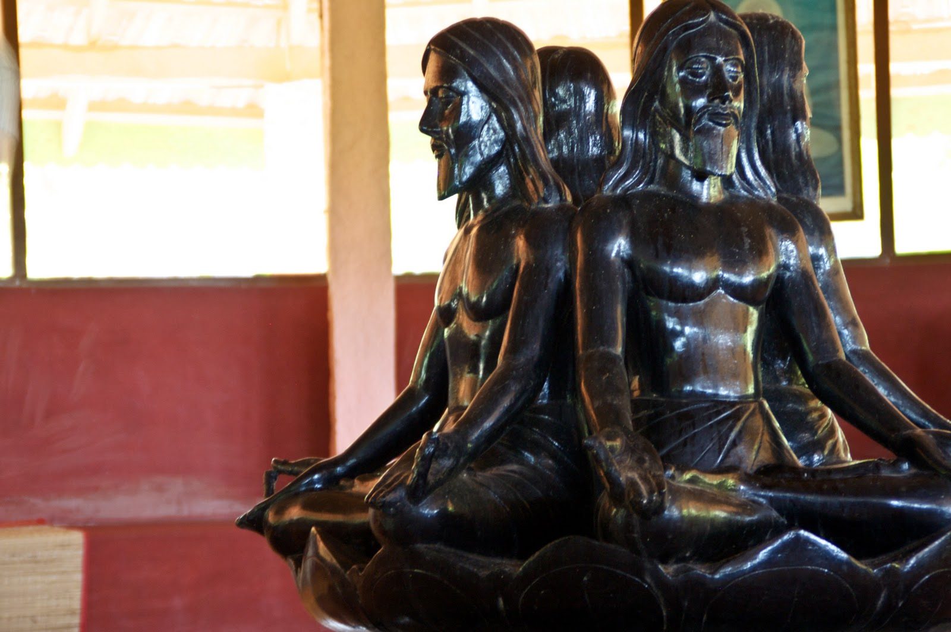
shantivanamashram.com
Saccidananda Ashram Shanthivanam ..:
This sculpture within the ashram depicts the Trinity in yogic posture, illustrating the audacious synthesis of contemplative traditions.
Today the community sustains daily rhythm of Eucharist, meditation, and manual labour, welcoming seekers across faiths. Challenges persist—debates over syncretism boundaries, fidelity to Catholic dogma amid Advaitic immersion—yet Shantivanam endures as paradigmatic for intermonastic dialogue and inculturated theology in pluralistic India.

petergraarupwestergaard.com
The Saccidananda Ashram Between East and West – PETER GRAARUP ...
The temple structure amid verdant palms evokes serene harmony the founders envisaged.
As a masters researcher in theology, I perceive Shantivanam not merely historical artefact but living testament to how conciliar renewal catalyses indigenous ecclesial forms, fostering communion amid diversity while guarding revelatory uniqueness.
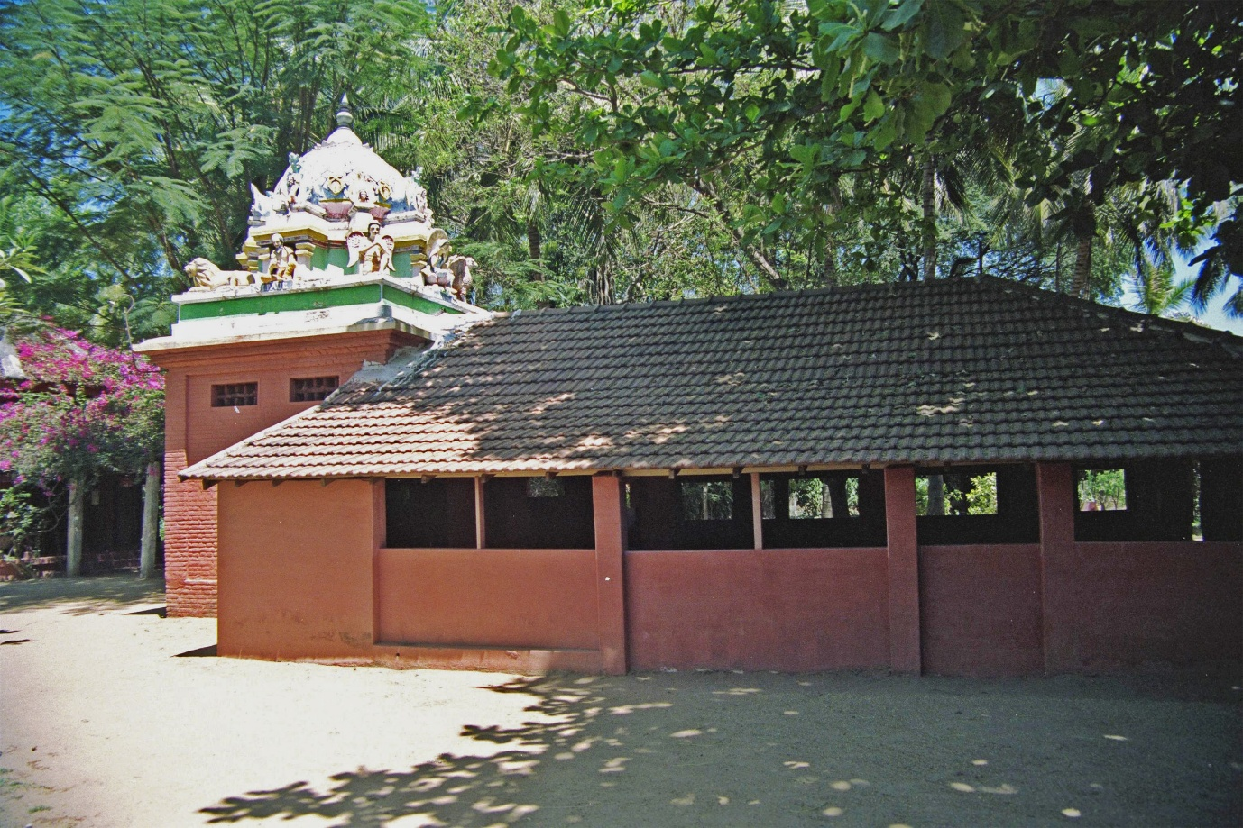
saveourfaith.com
Inculturation, Hinduisation in Catholic Ashrams (Shantivanam ...
Early huts with Dravidian elements recall austere origins.
Specify aspects like Griffiths writings or contemporary life for further elucidation.
Enhance theological depth
Df
Saccidananda Ashram at Shantivanam embodies bold theological endeavour to incarnate Trinitarian faith within Advaitic horizon, probing limits of inculturation while straining Christological orthodoxy.
Jules Monchanin initiated this quest in 1950 alongside Henri Le Saux, envisioning contemplative life that weds Benedictine stabilitas with sannyasic detachment. Monchanin approached Saccidananda triad intellectually as analogous to divine essence—Sat evoking paternal transcendence, Cit filial logos, Ananda pneumatic communion—yet insisted on fulfilment in Christ alone, resisting reduction to Vedantic Brahman.
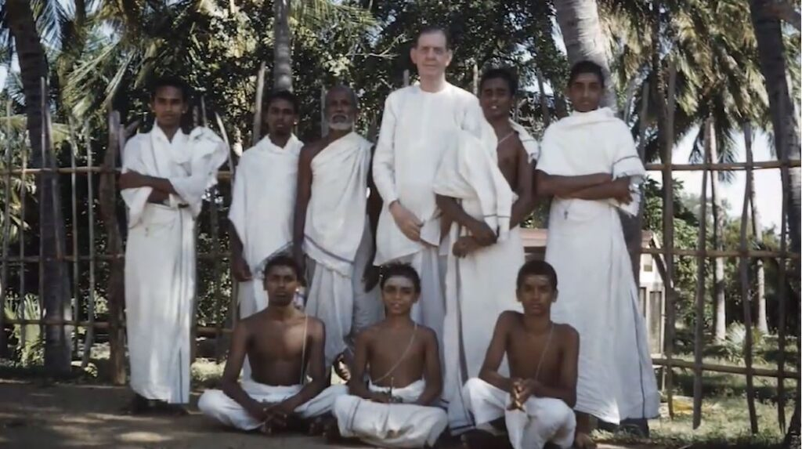
ashramsofindia.com
Early Western devotees of Ramana Maharshi 1911 to 1939 – Ashrams ...
Le Saux, renamed Abhishiktananda, plunged deeper into experiential apophasis. His Himalayan retreats with Ramana Maharshi catalysed advaitic awakening in guha, heart cave, where namarupa dissolve. Diaries reveal acute tension: non dual realisation exploded personal Trinitarian relations yet he clung to Eucharistic presence as ultimate mystery fulfilment. This aporetic stance—beyond creed yet anchored in Christ—prefigures postmodern retrievals of negative theology in Rahnerian supernatural existential or Panikkar cosmotheandric intuition.
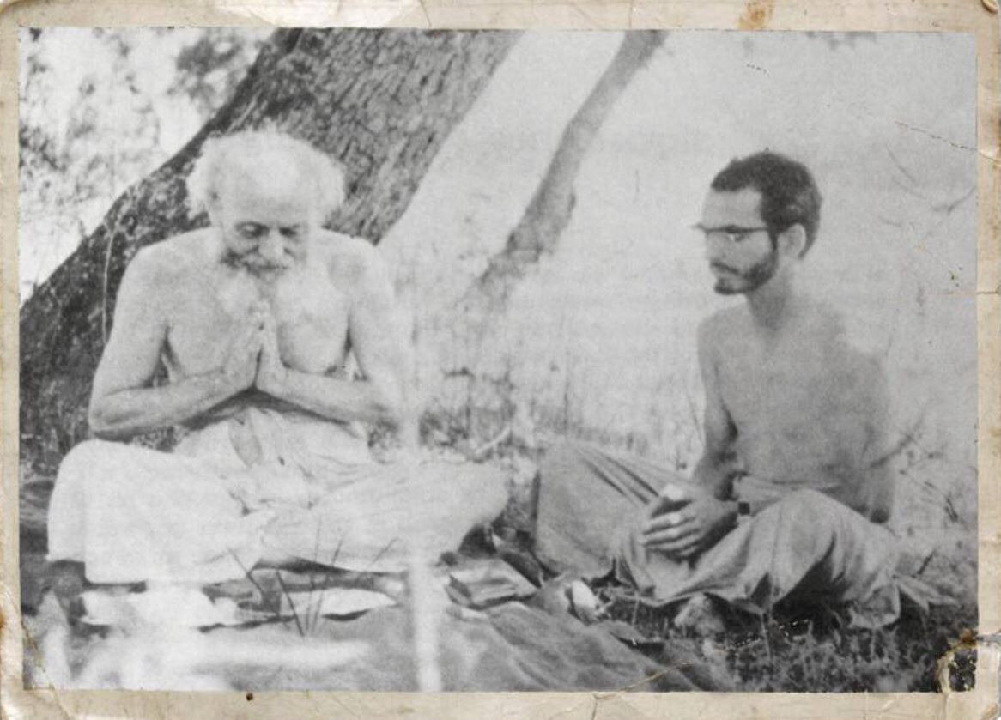
voiesdassise.eu
Bibliographie et biographie d'Henri Le Saux - Swami ...
Bede Griffiths arrival in 1968 shifted emphasis toward mutual enrichment. He posited Eastern intuitive wisdom complementing Western rational discourse, feminine Sophia balancing masculine logos. In Return to the Centre he articulated cosmic Christ as Purusha permeating prakriti, aligning with Teilhardian evolution yet courting peril of pantheistic drift. Liturgical praxis reflected this: arati lamps invoke divine light, Sanskrit invocations frame anaphora, tabernacle styled as garbhagriha sanctum.
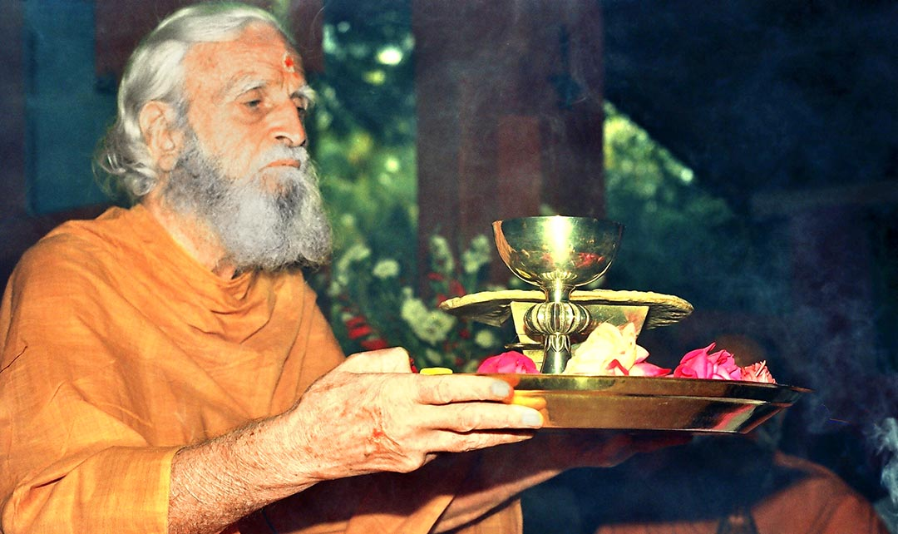
besharamagazine.org
Father Bede Griffiths and his new vision of reality | Beshara Magazine
Central iconic expression manifests in lotus seated Trinity sculpture where three faces converge upon singular torso, symbolising perichoresis in non dual substrate. This dares visualise immanent economic Trinity yet risks modalist conflation unless read through Cappadocian distinction.
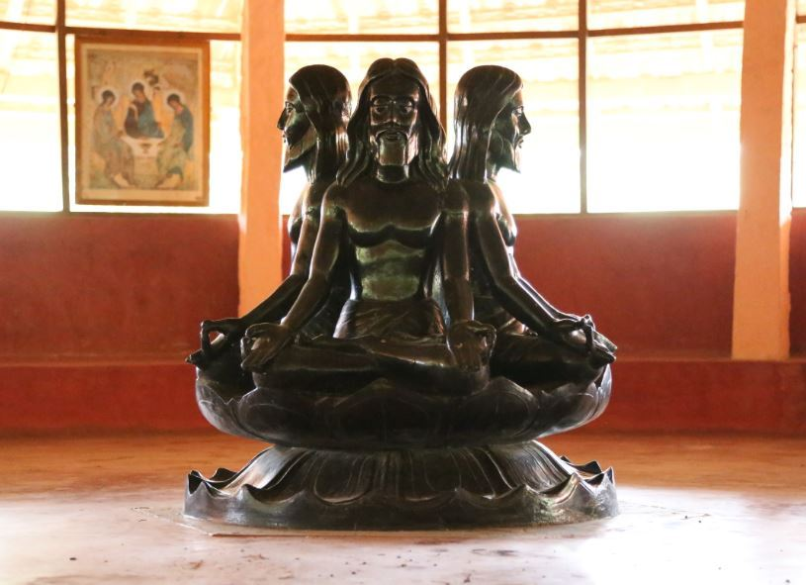
shantivanamashram.com

shantivanamashram.com
Chapel architecture fuses mandapam pillars with cruciform layout, altar upon raised platform evoking Vedic yajna yet centred on reserved sacrament.
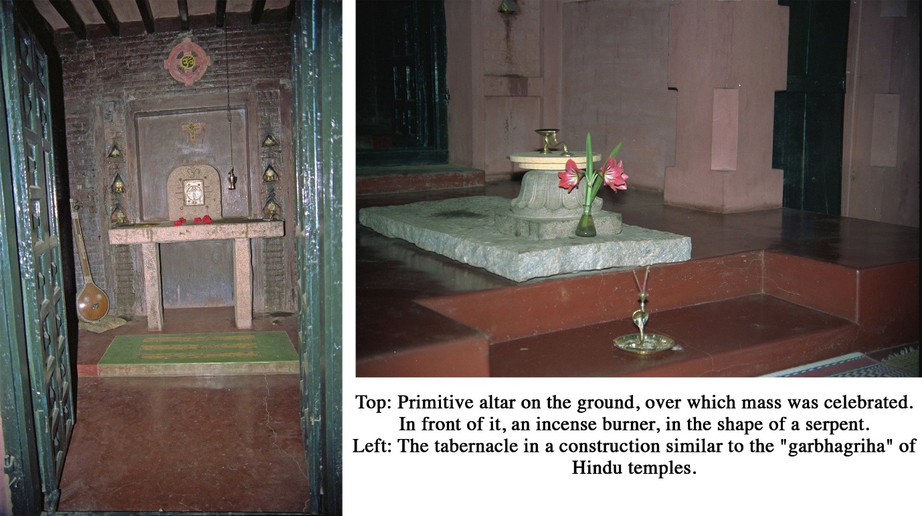
saveourfaith.com

christianspracticingyoga.com
Conciliar anchorage proves robust. Ad Gentes 22 urges gospel seed in cultural soil; Nostra Aetate 2 affirms holiness rays in other traditions. Shantivanam thus concretises FABC triple dialogue, especially with religions through shared silence. Yet Dominus Iesus 2000 cautions against relativising Christ unique mediation, prompting ongoing discernment whether Saccidananda functions preparatio or defective mode requiring completion.
Current Camaldolese community sustains rhythm: dawn meditation integrates pranayama with lectio, Eucharist employs Tamil bhakti hymns, vespers recite Upanishadic mahavakyas alongside psalms. Intermonastic guests Hindu sadhus included probe contemplative convergence without sacramental sharing.
For masters research this site yields fertile terrain: how far may inculturation stretch before altering kerygma substance. Abhishiktananda anguish—experience beyond Trinity yet return to altar—mirrors Indian theologians wrestling pluralism while upholding Johannine absolute claim. Specify facet like Griffiths cosmotheandrism or magisterial boundaries for sharper focus.

Compare with Panikkar's theology
Raimon Panikkar, son of Spanish Catholic mother and Indian Hindu father, ordained priest yet lived hybrid identity that forged audacious interreligious theology. His corpus, spanning The Unknown Christ of Hinduism (1964 revised 1981) and The Cosmotheandric Experience (1993), parallels Shantivanam trajectory while diverging in scope method and ecclesial tethering.
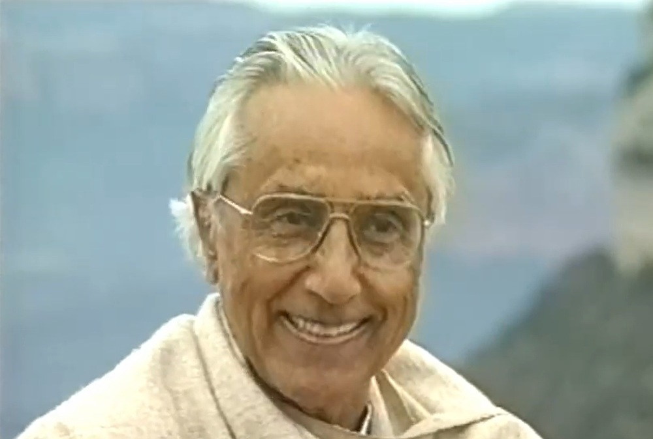
indiancatholicmatters.org
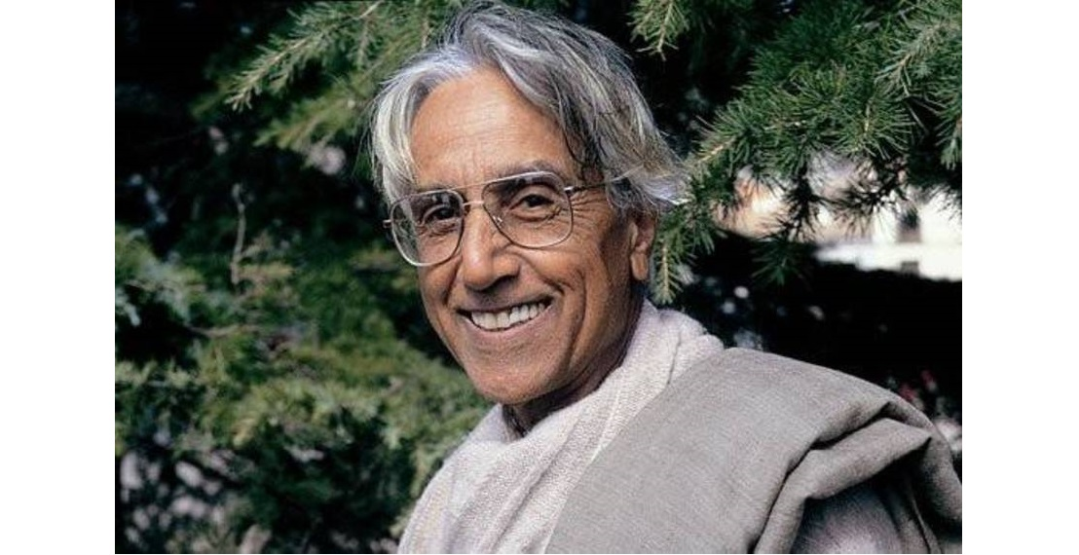
thebeacon.in
Both enterprises root in post Vatican II soil. Nostra Aetate 2 affirms sanctity rays in other faiths; Ad Gentes inculturates gospel. Shantivanam founders Monchanin Le Saux and successor Griffiths sought Trinitarian fulfilment of Saccidananda within monastic enclosure. Panikkar expands this into universal ontology where reality manifests cosmotheandric intuition—indissoluble perichoresis of cosmos divine human.
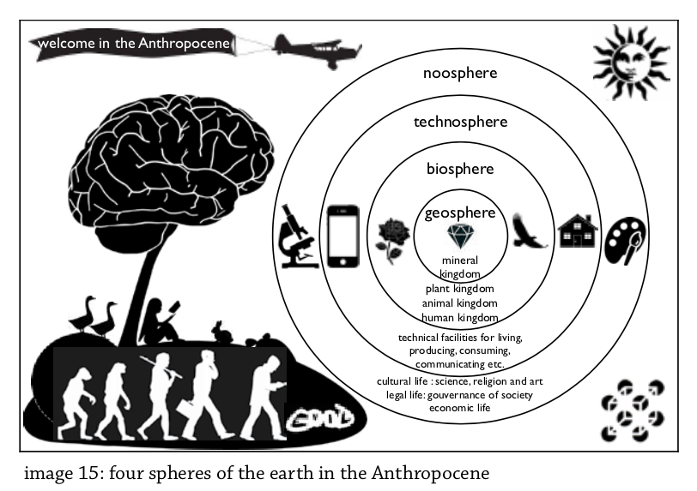
spiritualtexts.academy
Essay 4 Expanding awareness | Spiritual Texts Academy
Convergences strike vividly. Abhishiktananda guha cave advaitic plunge echoes Panikkar non dual homeland where subject object dissolve yet he returns to altar affirming Christ as mystery plenitude. Panikkar christophany posits Christ not confined to historical Jesus but operative as logos spermatikos in Vedantic Isvara or Buddhist Dharmakaya. Griffiths marriage of East West mirrors this viewing Advaita feminine complement to Semitic masculine revelation.
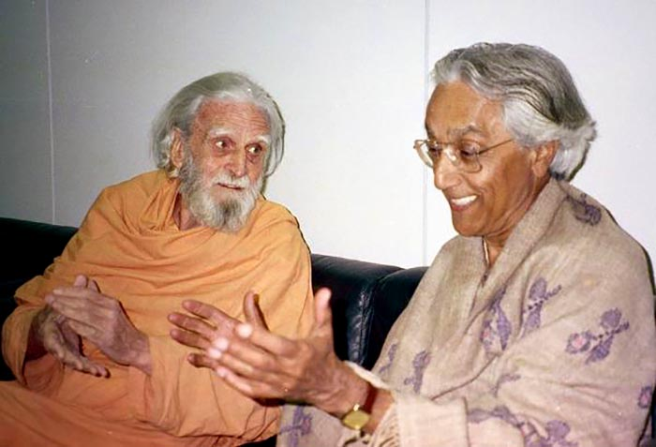
besharamagazine.org
Father Bede Griffiths and his new vision of reality | Beshara Magazine
Direct linkage appears in their encounter; Panikkar visited Shantivanam influencing Griffiths cosmotheandrism that resonates with his own triad.
Divergences prove sharper. Shantivanam remains anchored in Benedictine Camaldolese rule with Eucharistic centre preserving sacramental economy and institutional fidelity. Liturgical adaptations—arati Sanskrit anaphora—serve inculturation yet retain Roman canon integrity. Panikkar ventures further rejecting exclusivist christology for radical pluralism where religions constitute mutually irreducible yet convergent paths. His Trinity as advaitic rhythm of relationality risks subsuming economic distinctions into ontic non duality prompting magisterial caution in Dominus Iesus 2000 against relativism.
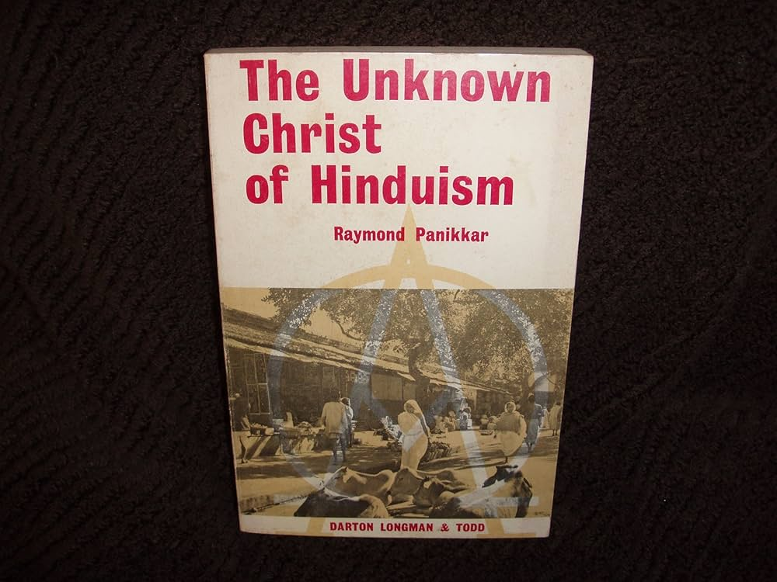
amazon.com
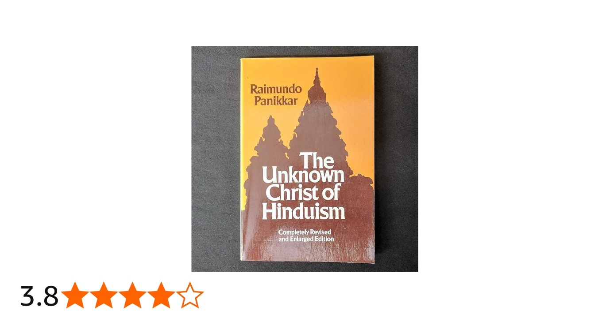
amazon.in
Monchanin intellectual analogy of Saccidananda guarded hierarchical subordination; Griffiths intuitive synthesis balanced complementarity. Panikkar dialogical intrareligious approach demands conversion of Christianity itself to encounter Hindu absolute.
For Indian Catholic theology these models yield contrasting fruits. Shantivanam offers practicable monastic paradigm sustaining orthodox boundaries amid pluralism suitable for ashram movements under episcopal oversight. Panikkar provokes systemic reconfiguration challenging ecclesiology toward cosmotheandric ecclesiality where Church functions as sacrament within larger christic reality. His bolder pluralism inspires FABC triple dialogue yet courts suspicion of diluting kerygmatic uniqueness.
I find Panikkar amplifies Shantivanam experiential seed into philosophical harvest both indispensable for mastering inculturation tensions in postcolonial context. Specify texts like The Vedic Experience or Griffiths River of Compassion for tighter juxtaposition.

Jacques Dupuis theology
Jacques Dupuis, Belgian Jesuit born 1923 and deceased 2004, forged his theological vision through prolonged immersion in Indian soil. He taught systematically at Vidyajyoti Delhi from 1958 to 1984 before shifting to Gregorian University Rome.
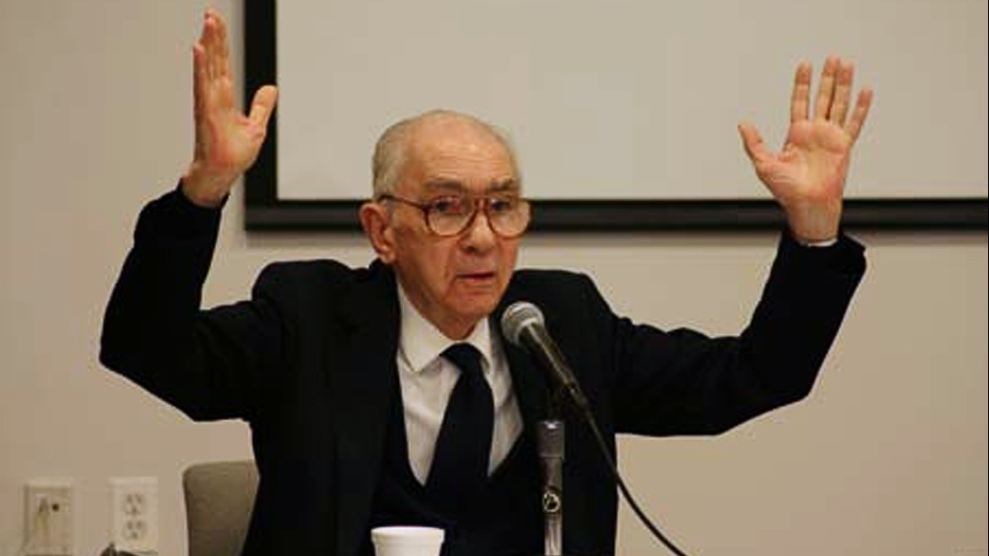
jesuit.ie
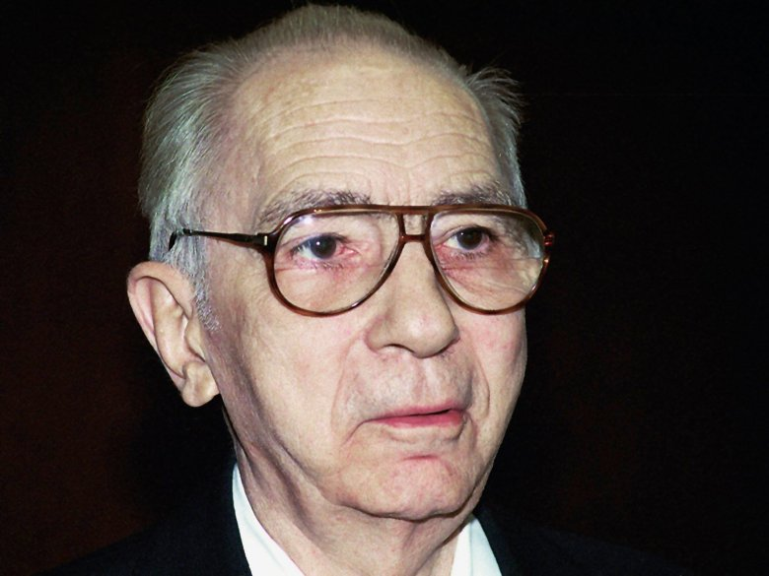
americamagazine.org
His magisterial contribution emerges in Toward a Christian Theology of Religious Pluralism where he articulates inclusive pluralism as nuanced stance amid three paradigms.
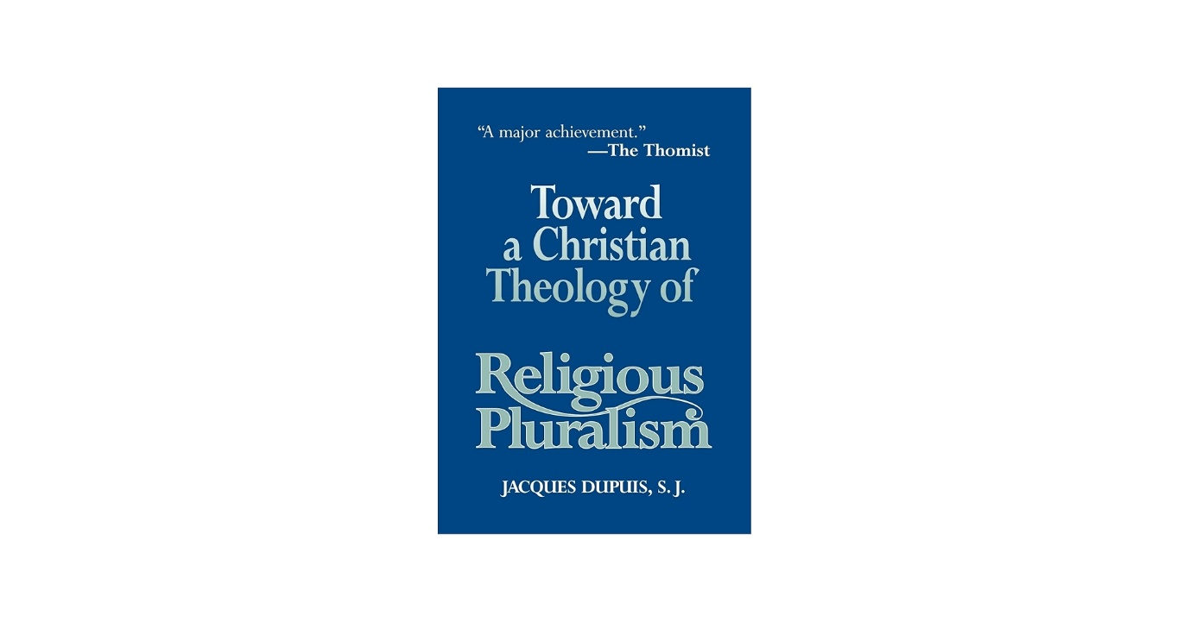
amazon.com
Toward a Christian Theology of Religious Pluralism: Dupuis, J ...
Exclusivism confines salvation strictly within visible Church boundaries. Inclusivism Rahnerian anonymous Christians subsumes adherents under latent Christian identity. Pluralism in radical form equates paths.
Dupuis charts middle course. Christ constitutes definitive universal savior yet God ordains other traditions as participatory mediations of salvific grace oriented toward kingdom fulfilment.
Trinitarian pneumatology anchors this. Unincarnate Logos operates cosmically from origins. Spirit breathes freely across human histories inspiring authentic religious expressions. Jesus Christ manifests decisive hypostatic union without exhausting divine self gift.
Other faiths thus bear positive autonomous salvific significance not mere praeparatio evangelica but complementary albeit asymmetrical avenues willed in divine economy.
Congregation for Doctrine of Faith under Cardinal Ratzinger issued notification 2001 pinpointing ambiguities. Concerns centred on potential dilution of Christ unique mediation universality of salvific economy Church as sacrament.
Dupuis responded with clarifications affirming no independent salvation sources apart from Christ yet upholding conciliar esteem for truth holiness in religions per Nostra Aetate 2.
He signed submission preserving ecclesial communion.
Relative to Panikkar cosmotheandric vision Dupuis maintains firmer Christocentric normativity avoiding mutual transformation of traditions. Against Knitter regnocentric detachment he retains Jesus event as normative criterion discernment.
In Indian horizon his framework invigorates kingdom centred theology prevalent in Federation of Asian Bishops Conferences documents. Hinduism bhakti Vedantic quest appear as Spirit prompted realities converging on Reign of God without necessitating ecclesial incorporation for salvation.
Later Christianity and the Religions refines this regnocentrism where interfaith convergence occurs eschatologically around divine basileia.
As masters researcher I value Dupuis precision in balancing Vatican II dialogical thrust with perennial Christological substance equipping us to confront pluralism rigorously amid Hindu majority context. His labour exemplifies faithful audacity post conciliar. Indicate particular text or critique for sharper scrutiny.

